MALE SOCIAL PARTICIPATION AND VIOLENCE IN URBAN BELIZE:
SUMMARY

July 26, 2010
McField Conference Room, Chamber of Commerce, Belize City
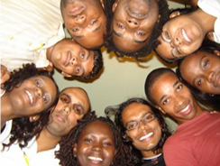

Dedicated to all the youth of Belize and the social service providers who understand them and their importance to the development of the country
Herbert Gayle, PhD
Anthropologist of Social Violence,
The University of the West Indies, Mona Campus, Jamaica
AND
Nelma Mortis, MEd.
Ministry of Education, Belize City, Belize
WITH
Jamuna Vasquez; Raymond James Mossiah, MSc.;
Melvin Hewlett, BSc.; Alindy Amaya, MA
Acknowledgement
There are a number of individuals and groups of persons without whom this study would not be realized. We wish to use this medium to publicly thank them for investing their time and money. God bless you all:
First, the Respondents: the youth of urban Belize who were happy to tell their stories; the teachers and administration of the many schools that allowed us to interrogate them and the children in their care; the parents who gave us permission to interview their children and who spoke to us truthfully about their family situations; the police officers of varying ranks who helped us to understand their challenges; members of the judiciary who helped us demystify matters of the law; the merchants who explained to us how economic development is possible in the Belizean environment; the social providers that pointed out to us some of the missing links in the social system of Belize; the staff and selected inmates of the Belize Central Prison; and even the turf protectors of colours red and blue who decided that they would confide in the team principal, Herbert Gayle, and explain why they were involved in the game of war.
Second, the Research Team: Herbert Gayle, Nelma Mortis, Jamuna Vasquez, Raymond Mossiah, Melvin Hewlett, Alindy Amaya, and Miguel Segura who formed the research core and carried it to fruition; but special thanks also to Douglas Hyde, Kevin Cadle, Lorna McKay and Nicole Haylock who had to leave the team due to other commitments.
Third, the Financial Support Team: The Ministry of Education, Ministry of National Security, Ministry of Youth, Office of the Prime Minister, Belize Social Security Board, Crime Stoppers Belize, Conscious Youth Development Programme, National Committee for Families and Children, Old Belize, Banana Enterprises Ltd., Belize Natural Energy Trust, Belize Telemedia Ltd., Fort Street Tourism Village Ltd., Joseph and Taylor Ltd., MNM Hardware and Service Station, St. Catherine Academy, John Woods, Cisco Woods, Brigadier General Lloyd Gillett, Sean Feinstein, Dora and Allan Duncker, Evan ‘Mose’ Hyde, Eliane Bou-Nahra, Kevin Herrera, Yolanda Schakron, Yvonne Moore.
Fourth, but not least important, Media Support: Krem Television, Krem Radio, Amandala Newspaper, Chanel 7, Chanel 5, Love Television, Love FM, Belizean to the Bone, and Plus Television.

The report has ten chapters, divided into four sections.
- The first is the Introduction comprised of the Research Design or methodology and the Critical Background.
- The second section is an Assessment of the Human Ecology of Belize with emphasis on the urban centres, where social violence is concentrated. It is comprised of three chapters and is a discussion of the ‘pre-conditional’ areas of the human ecology that contribute to social violence. These are the areas of a society that socialize and or nurture its populace: home, school and community. In the latter we have selected those institutions that comprise the central political authority, responsible for discipline, justice and equality. A breakdown in any of these institutions creates major crises leading to social violence.
- The third section is the Male Social Participation and Violence which is comprised of four chapters focused on the crisis of youth living in and affected by violence, with the emphasis on boys. The section begins with an Animated Life History of the very young children, ages 6-13, followed by a PEER analysis of youth, then an Integrated Trauma Survey, and ends with a chapter on Gang Formation and Maintenance in urban Belize.
- The final section is the Summary and Suggestion.
RATIONALE: How and Why the Research Project Started
In November 2007, at the Sub-regional CARICOM/UNICEF Conference on the state of Boys and Education, held at the Princess Hotel, Belize City, the Belizean representatives expressed serious concern for the pattern of male neglect and violence evident in Belize City. Persons described the situation of male neglect and social participation as a time bomb. This statement was not intended to be a prediction. Members of various organizations continued to express concern, including UNICEF, National Committee for Families and Children (NCFC), as well as personnel of the security forces. Despite the harsh reality, a large proportion of Belizeans simply observed the crisis from their tropical verandahs. The ‘Caribbean lethargy’ was however shaken by an incident:
“When the Mayflower Street grenade attack occurred on May 21st, (2008) it was as if something changed irreversibly in Belize,” (7 News, Belize).
One may argue that that was a frightening day that should be seen for the disaster it was and nothing more - but it actually marked a positive rebirth in Belize. About thirty persons from various organizations including Mothers Organized for Peace, UNICEF, Belize City Council, Belize Health Care Partners, Youth for the Future, Conscious Youth Development Programme, Belize Family Court, Human Rights Commission of Belize, National Drug Abuse Control Council, Community Rehabilitation Department, and the National Committee for Families and Children took the incident as a wakeup call. On June 11 – 12, 2008, led by the NCFC, social practitioners came together and started a chain of events that could lead to lifelong changes in Belize, most important of which is the reduction of social violence. The Think Tank identified several social problems that needed to be addressed but recognized that some required special expertise not available in Belize. Dr. Herbert Gayle of The University of the West Indies, the region’s only anthropologist of social violence was contacted. He conducted a series of workshop and forum on the situation analysis of the problem of social violence in Belize. Through all the workshops and forums facilitated by Dr. Herbert Gayle, practitioners and government agents lamented that Belize lacked some of the three key drivers for social change which are: Knowledge, Resources, and Political and Public Will. Without them not even the readiness stage of change is possible.
Given the situation in Belize of tremendous political and public will but low levels of knowledge on social violence and a lack of training in the advanced research tools needed to study the problem, all the participants of workshops held, and Government personnel involved suggested that a comprehensive research be done covering urban Belize (with focus on Belize City and Cayo). Given Dr. Gayle’s social violence expertise and that of his being one of the only scholars in the region trained at the advanced level in all four methodological approaches (which led to his selection to study the problem of male social participation for the Government of Trinidad, as well as for the Principal of the University of the West Indies, Mona Campus), the suggestion was for him to train a cadre of Belizeans, drawn from the Ministries of Education, National Security, and the University of Belize in the latest cutting edge research methods to collect the relevant data so as to guide policies and reduce violence to a manageable bar by the year 2020.
The research design or methodology details the research effort constructed on a frame of 12 different research tools dove-tailed in a way to produce a massive research that covers close to every critical area of life that produces the violent response of the male youth of Belize. Eight of the tools are the core (in Table 1) and 4 others used as complementary.

Table 1: The Sample and the Core Research Methods
RESEARCH TECHNIQUES | AGE | M | F | TOTAL
ANIMATED LIFE HISTORIES | 6-13 | 58 | 34 | 92
PEER | 13-22 | 82 | 42 | 124
INTEGRATED TRAUMA SURVEY | 12-21 | 175 | 178 | 353
PLA ASSISTED FOCUS GROUPS | 16+ | 102 | 101 | 203
COMMUNITY FORUM | 13+ | 333 | 167 | 500
IN-DEPTH INTERVIEWS | 16+ | 40 | 8 | 48
CASUAL INTERVIEWS | 13+ | 150 | 60 | 210
QUANTITATIVE HOUSEHOLD SURVEY | 13-23 | 336 | 344 | 680
TOTAL |  | 1276 | 934 | 2210

The research questions:
- What is the web or causal flow of factors that account for the problematic social participation of young males and the related high levels of social violence in urban Belize among young men, particularly those living in the areas of extreme poverty?
  - What are the constructs of the human ecology that is producing high levels of conflict among young men?
  - What are the critical social service providers that are functioning and not functioning that result in the male youth crisis studied?
- What is needed to create and sustain a frame of change programmes related to violence reduction and youth inclusion with special emphasis on positive male social participation?
The study concentrated on the three major towns of Belize: Belize City, Belmopan and Cayo.

The Research Sites
Chart 1: Research Sites and the Research Emphasis
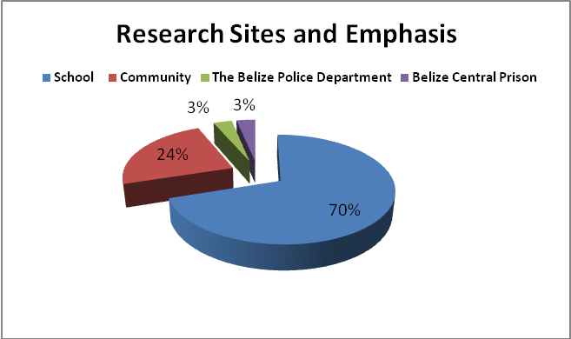
The study is largely integrated and qualitative. Qualitative and integrated research depend very heavily on triangulation for confidence. Five different methods of triangulation were employed in this study: methodological, source or data, researcher, theoretical, and time. Triangulation means the examination of a problem from three or more angles. In this study 12 different research tools were used to collect the data, eight of which are the main tools, with others used as modes of re-check or methodological triangulation. The research team was trained to collect data related to a single matter from various persons or sources. In other words if a ‘story’ is related about a person or setting it has to be verified by interviewing several other persons of various ages and status before it is accepted as ‘worthy of being documented’. Each researcher was purposively selected based on gender, analytical skill, knowledge of Belize, and research experience. In so doing various perspectives were brought together as the researchers interpreted the data. The study is built on several theoretical frames.
Finally, the research project started in April 2009 and lasted for 14 months which allowed for longitudinal examination of some of the core problems. Researchers were also trained to interview persons and visit areas, including those considered volatile, at varying times of the day to allow for seasonal observation, rather than a series of the same snapshot of the lives of people.

The Research Frame
The study was meticulously framed to meet its objectives. The model is that of four circular spheres, each connected to the other and studied in a way to help provide a complete picture of the human ecology of the core, which is the youth of urban Belize. The results therefore reflect an examination of the opportunity structures and agencies of all urban youth in Belize; starting with the males living in the most urban setting, who are most likely to participate in social violence, to the ones living in centres that are urbanizing but do not yet have the hostile human ecology that fosters violence; and certainly including a critical assessment of the ‘drivers’ of Belize, whose function is to serve as the social service providers of the next generation, including families, teachers, guidance counsellors, principals, the church, merchants, medical personnel, government social services, non-governmental organizations, community-based organizations, the judiciary, the police and penal system; and finally all households, their construction and function and how this impacts on the three spheres within Belize. These households include rural ones that serve as a comparative point of assessment for urban Belize. This research frame is displayed in the Figure 1 below:
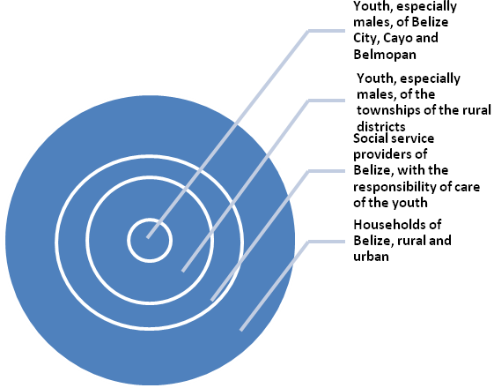
Figure 1: The Research Frame

Brief Situation Analysis
Belize, which though politically Caribbean, located on the Central American corridor adjacent to Mexico, joined the top ten most violent countries during the shift of the drug trans-shipment route from the Caribbean to the Central American corridor. As shown in Chart 2, at the turn of the decade Belize had only 16 murders per 100,000. Within two years (2002) Belize had it first major spike in murders to 29 per 100,000 and went into social shock. The following year it declined somewhat but steadily rose to 32 per 100,000 by 2007, crossing the civil war benchmark, and achieving the status of being the second (behind Jamaica) most violent region in the Caribbean. In 2008 Trinidad exploded, shifting Belize to a ‘not much better’ position of third in the region.

Chart 2: The Most Violent Caribbean Countries
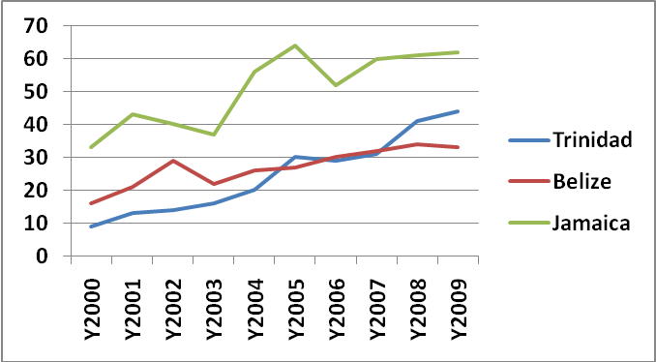
Data Sources: United Nations Office on Drugs and Crime, national statistics for individual countries.
The Belizean Family and Social Violence
The Belizean family has the advantage of having a large proportion of couple families when compared to other developing countries. This is due to the strong representation of rural and highly religious people in its population. In other words, Belize has not yet fully urbanized and is still largely traditional, rather than secular. Undoubtedly, at 52 percent urban, Belize is in transition from rural to urban. This can be seen in the large area now listed by the country’s Statistical Institute as rural, but is actually already peri-urban as they are urbanizing very rapidly and no longer enjoy village life, but rather are active dormitory and copycats of the town located in close proximity. This area is 18 percent of the sample, suggesting that within a decade Belize will have another fifth of its population declared as urban. As a country develops it is expected to urbanize. The problem with Belize in this transition is that it is urbanizing without shedding some of the fetters, and the process is too fringe-driven or accidental.
One of the major fetters of development is the large sized family that has been carried over into urban life. Large families are good in rural spaces but certainly contribute to poverty and frustration in urban ecologies, as they have too much of a gap between earner and dependents – and without an abundance of cheap or subsistence food, and without the social capital of sharing that characterizes rural life. In a developing country with major economic challenges, families with households of over 6 persons in urban spaces are at major risk of fracturing. The study has shown that a half of all urban families have been forced to drop the stable rural nuclear form and establish forms that can deal with the dependency crisis. Hence the extended family becomes the primary rescue family form, followed by the stepfather couple form, next the single-mother, and finally at the peak of economic and social crisis, the alternative family, which is an extension of the extended family but without any biological parents of the children adopted.
The nuclear families in urban Belize have high financial stability and inversely low levels of conflict, and hence provide good emotional support for most children. Conversely, the adaptive family forms have had problems in achieving stability. For economic and other reasons, they are located in less stable human ecologies (they created to some extent); their heads and supportive adults are more likely to be female and poor, which imply that adolescent boys often lack the benefits of the splintered roles of fathers, and are likely to seek emotional support outside, including on the streets. Mothers have, however, aggressively replaced many of the biological fathers with stepfathers, but these families carry a new set of problems for boys. Southside has the weakest ecological footprint or most problematic environment. Two-thirds of the fathers are missing and 83 percent of the adolescents are either aggressive or moderately, with no parallels anywhere else in Belize. The reality is that despite the monotrophic bonding between mother and son, which is extreme up to age five, after that age fathers’ presence and function become critical for boys; and families need the right ecology where fathers are present and powerful for boys to remain stable. The Government of Belize has much to do to empower families. Obvious the family needs greater support in order to support the efforts for development.
The Education System: Carrying Water in Baskets
The issue is that while the education system of Belize is certainly failing boys – it is failing girls as well – as it is carrying water in baskets, instead of buckets. Dramatic changes must come in the immediate future in its structure of operation, followed by the creation of a more supportive human ecology, if the education system is going to work to meet millennium goals for the youth of the country.
There are three broad problems militating against the education system meeting its millennium goals.
- First, school resources are not enough to address the needs of the nation’s children, and hence it is leaving a mass of children behind;
- Second, the school system is outdated and structurally flawed, set on a colonial frame that no longer exists in the region, one that operates to produce only a few elite students, like a fancy basket that needs to be changed to at least a cheap bucket that can hold water;
- Thirdly, the 59 schools studied are facing numerous challenges brought on by poverty and vulnerable, violent human ecologies, and poorly developed facilities for youth countrywide. This forces the schools to operate as welfare centres and robs teachers of time and energy to teach.
Social Exclusion and the Current Education System
The figures in Table2 suggest that Belize has an extremely high school exclusion rate which has to be treated as a core contributing factor to the gang problem in Belize City and other urban centres.
Table 2: School Exclusion at the Primary and Secondary Levels
Education Level | Gender | Population | Net Enrolment |  | Excluded |  | Percentage Excluded
PRIMARY | M | 35,587 | 29,423 |  | 6,164 |  | 17.3
PRIMARY | F | 34,011 | 28,801 |  | 5,210 |  | 15.3
PRIMARY | Total | 69,598 | 58,224 |  | 11,374 |  | 16.3
SECONDARY LEVEL | M | 16,895 | 6,314 | 10,581 |  | 62.6
SECONDARY LEVEL | F | 16,322 | 7,193 | 9,129 |  | 55.9
SECONDARY LEVEL | Total | 33,217 | 13,507 | 19,710 |  | 59.3
ALL STUDENTS |  | 102, 815 | 71,731 | 31,084 |  | 30.2
Source: Planning & Projects Unit, MOE, 2009
- A third of all children are excluded from education by the state’s inadequacies. At the primary level there are 11,374 excluded children. The excluded children represent 16.3% of the population of students at this level.
- These calculations cannot however be matched against the rest of the Caribbean and Latin America because Belize still maintains a peasantry elementary system where children remain in primary school until Standard VI, which is equivalent to grade 8 in secondary schools universally. By aligning primary and secondary level exclusion we can extrapolate that the exclusion of Belizean children ages 6 to 12 years old (internationally recognized as primary school age) is actually about 14 percent. Having done so, we can calculate the country’s position in terms of achieving the millennium goal of Universal Primary Education by 2015. The current situation is that Belize is far behind the rest of the Caribbean and Latin America, which in 2007 had only 7.2 percent of its children ages 6-12 out of school (UNESCO 2008).
- The problem becomes alarming at the secondary level. Here almost 60% of all the children are missing and out of place. It is important to note that while boys are more excluded than girls overall, the gender difference in exclusion in the transition from primary to secondary is not significant. Males make up 54.2% of all children excluded between standards 1 and 6. Notice also that this proportion is basically the same at the secondary level where males account for 53.7% of the excluded. These figures suggest that there is no significant gender discrimination in the failures of the education system – it is simply inadequate.
Chart 2: Increase in Exclusion in Transition from Primary to Secondary by Gender
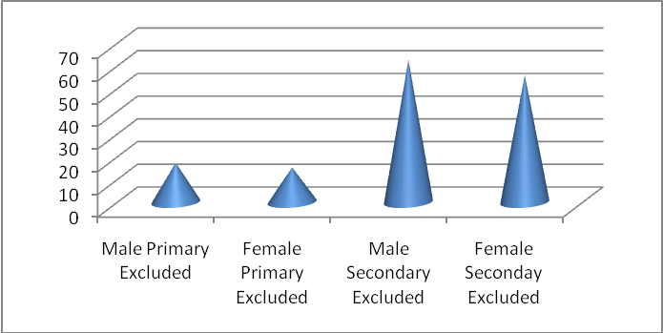

- Chart 2: shows the dramatic increase in exclusion for both sexes between standard 6 and ‘secondary’ school life. This exclusion is 4 times greater than it was in elementary school, resulting in baffling statistics that can only be explained as a system failure. Notice that almost two thirds of all males are excluded at this level, compared to one-fifth of their Caribbean counterparts.
- The 2007/2008 data from Ministry of Education suggest that annually 7.2 percent of primary and 7.7 percent secondary school children repeated the class for which they were enrolled in for the year, with boys doing so at a rate one and a half times that of girls. The annual drop-out rate for those years was 1 percent for primary and 10.5 for secondary, again with males one and a half times more vulnerable. Teachers calculated that boys are up to 3 times more likely to drop out at some schools due to poverty and violence-related issues.
- Given that education exclusion is twice the rate of the region at the primary school level and three times at the secondary school level, we can expect to find choking statistics about tertiary education in Belize.
Tertiary Education
- Data from UNESCO (2008) suggest that at 4 percent tertiary enrolment, Belize might have one of the worse rates in the region (See Chart3). On what foundations will a government build a country if the tertiary enrolment is unmentionable? Where will Belize get the technical and social skills to solve its problems and chart its way forward in this global whirlpool?

Chart 3: Tertiary Enrolment for 2007 for Selected Caribbean and Central American States

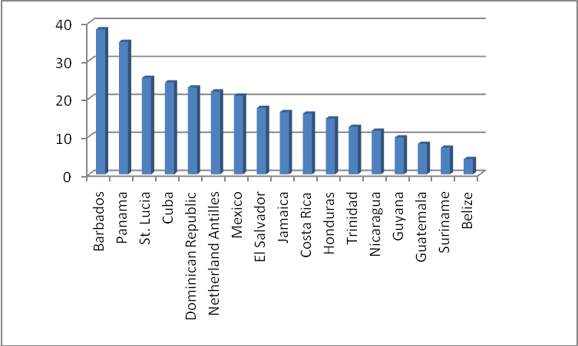

Source: UNESCO 2008

System Failure Caused by Outdated, Colonial, Mismatched Structures: Using Fancy Baskets to Carry Water
The inadequate funds, lack of programme planning for youth, and the immense poverty of households are largely to blame for the crisis in educating the nation’s children. Belize’s educational system is still based on the British colonial model.
- Largely to blame are the current problematic emphasis on primary education with secondary education as a trophy;
- the complicated system of school finance and management;
- the colonial education structure;
- and the poor response to these problems by some parents, teachers.

Fragile Central Political Authority
The central political authority of a country is the frame of control for a country. It is comprised of all the core groups responsible for organizing and controlling the actions of people to ensure that a society is stable and functioning. It is the compliance machine of a country and is therefore very critical. Weak central political authorities contribute to high levels of social violence. Institutions that function as part of the central political authority fall into four categories: political and administrative power, policing, judiciary, and social or civil society. In this study we assessed some of the core institutions of the central political authority under the first three categories in terms of their design or structure, capacity and position of readiness to achieve their objectives.
Political and Administrative Power and Efficacy
- In order to effect development a government needs a set of policies designed with its skill set and capital resources in mind. A process moves from plan to implementation to evaluation to amendment to sustainability. This process is very fragmented in Belize. Government personnel complained that Belizeans are good at planning and starting but not as good at implementing and “terrible at evaluating so they can amend and drive for sustaining good ones and weeding out bad ones.” One of the weaknesses of small states is that they lack critical skills set in human resource.
- The major crisis seems to rest in the absence of sector linkages and resources. If countries have large development plans they can achieve these objectives by either shaping ministries around these goals; creating statuary bodies or administrative committees that draw on various ministries to meet the development targets; or doing both.
- Budgeting is always a crisis for small poor countries. Often what is done is that the decision is made to increase allocation to one or two different critical ministries. However, few ministries can achieve major goals without success in the related ones.
- The mistreatment of the Ministry of Youth has been a major complaint from government personnel from both political parties. The tradition in Belize is to treat it as an attachment of some other ministry, some of which have been unrelated to youth issues
- The most vulnerable youth in urban Belize have two agencies upon which they can depend. One is the YFF (Youth for the Future) and the other is the (CYDP) Conscious Youth Development Programme. These two agencies have conflicting political roots. Both are very focused and are doing tremendous work with vulnerable youth, especially of Southside. These two units as picked up by the study, end up duplicating and not maximizing the country’s scarce resources. Any unit that is combined must get the full support aligned with the better funded unit or both sides will have regrets.
- Belizeans, especially sport reporters and sports enthusiasts are usually embarrassed by two sets of images. The first is that of the shockingly lacking sport equipment that is prepared for the nation’s youth. Most football fields look like cow pastures. Sport infrastructure is so bad that the country cannot even accept gifts from international groups, since the acceptance of such gifts require space and infrastructure before the court or field is laid. The second embarrassment is the response to the question: where do the greatest Belizean raw talents come from? Belizean talented youth from extreme poverty often go and represent their country, stay at five-star hotels where they grab all the chicken they can pack in their plates to the shock of their competitors from other countries, who take a balance meal of meat and vegetables. After returning home they depressingly disappear into a night of poverty from which they had emerged.
- In a country where there is a strong central political authority people are not be allowed to live in a morass and dump around them with garbage. Such pictures give the impression that people are on their own and there is little or no sense of parameters for social and physical action. Upon discussing the problem with Belizeans it became clear that there is a tradition of unplanned development

Policing: the Hostile Face of the State- There is a war going on between the youth of poor urban communities and the police. The police do not treat the youth with respect and hence they have no legitimacy. The youth therefore see no wrong in throwing stones at the police and attacking them whenever they can. They do not share information with them, nor do they relate to them as good representatives of the state. They are enemies at war. The level of corruption in the Police Department removes social distance between youth involved in criminal activities and the police
- Interviews and group sessions with over 70 police officers did not change any of the accusations that the public and gang members leveled at them; rather the police officers interviewed face to face validated the horrible things said about them with brutish honesty.
The problem is not made any better by the way the state treats the police. Police working conditions in Belize is incredibly horrible. Police told some stories that sounded so sorrowful they made you realize that they too are victims of the nasty structural violence caused by economics and class. These are the weakneses endured by police : Poor and Defective Equipment, Interfering Politicians, Promotion by Favour rather than Merit, Costly and Stressful Transfers, Frighteningly Low Salaries, No full time Chaplain or Counsellor, No Health Insurance
The Belizean Judiciary: No Conviction at this Time!
- One of the greatest problems with effecting convictions is the massive gap between the learned judiciary who are forced to follow procedures and poorly trained police officers who expect the former to work miracles.
- The court faces two major handicaps. The first is the lengthy delays caused by years of overload. It takes the court very long to conclude on a case and this is frustrating. “The court is so designed that it can be manipulated by counsel and even the defendant. Lawyers can ask for adjournment repeatedly. Mostly this is because they have an overload but other times it is manipulation of the over-burdened system. Defendants can also delay the time by asking for counsel very late and we have a duty to allow them such even when we are ready to have closure. The timing of a case can frustrate the parties involved and this can have bearing on the case. Even witnesses get frustrated and the implication is obvious.” As was deduced, some magistrates get so frustrated that they simply go home half way through the day of work. This is however not an excuse for all. There are times when magistrates simply leave before the day of work is over; but this has not been an everyday occurrence as far as judiciary respondents were concerned.
The biggest problem the court faces is lack of efficacy caused by weaknesses in the system that allows victims to haunt them, and perpetrators to walk free. The problem can be broken down as follows.
- Poor investigation
  - Poor training of police officers
  - Over burden of some critical police officers
  - Some cases are deliberately corrupted by experienced officers to ensure that the case fails
  - Gathering of evidence in many case is too lose – no structure and focus
- Poor case preparation
  - Poor response to site, many crime scenes are contaminated by the time they get there. There are numerous cases where anyone can enter the crime scene even though there are tapes. There are even cases where there are no tapes – so this reflects very poor police training.
  - Some sites are deliberately contaminated by experienced police.
  - Threats to the witness – persons are often too scared to provide the evidence or come forward and there are no forensic to back up the evidence
- Loose management of police human resources with the effect that unskilled persons are doing things they cannot manage. This is done by the practice of throwing persons into roles for which they have no training. A magistrate illustrated this problem: “For example a sergeant was transferred to me to serve as prosecutor. They assumed that he understands because he was at the sergeant level. The reality is that I had to train him which ought not to be. He was then sent to an organized training on the operation of the court system. So now I am happy. Suddenly he disappears. As soon as he was trained he was needed for a new operation. So the issue is that he is not here and the problem could repeat. So I must train another one!
- Poor communication and blaming of each other – CIB blames the court, we blame CIB. So very few persons understand how the system of processing cases work; and very few of us who understand work well together. It means therefore that sometimes it is difficult to charge a cop that is branded corrupt as you cannot even tell if he understands the system well enough to have effected good case preparation.
- Corruption among magistrates and lawyers – Breach of regulation among magistrates is not uncommon. At one point it was common. This group is much better but they are not all blameless. Some lawyers are retained at one special court and this means that the criminal and the lawyer can work together to reduce the effect of the court. The case becomes predictable. Why should the same lawyer and judge be working together all the time for prolonged period – this lends itself to corruption. When things get too hot in the arranged court it is transferred and sometimes it is thrown out. However, sometimes it is sent to a very serious and straight judge who convicts to their horror. People who know the system very well are clearly among the perpetrators. One scam is clearly the matter of splitting of bail. A judge set a high bail and then there is extortion to split the bail. Sometimes it is the police officer who negotiates on the half of the accused, other times it is the lawyer. “I have even seen the news reporter get in on the scam.” The person who gets the magistrate to split the bail so it is easier to pay gets an informal fee. The truth is that some judges do not know of the hustle but in the past we have heard of a few who set up the hustle themselves. “The way around this is to inform the accused up front that he can get the bail split so no one can hustle him. That is justice and that is our task!”
- Protection of pride – The judiciary is the last bastion of a society. Its pledges, the magistrates are very unlikely to report to the public any problem, which would embarrass the esteemed professional garrison. “We know of the problems but we do not want to be embarrassed so we leave it be and that makes the system get worse until now it is too bad. At least I see signs of repair.”
- Political corruption and Interference – It is very clear that some politicians who have symbiotic links with gangs and grassroots criminals enjoy the weaknesses of the system. They use the system to let their illegal bodyguards get away and soon they feel that they are untouchable. “People have become so brazen now that they stay right in the court with the recorder running and threaten people. They know the system can be beaten.” Politicians need to allow the courts to run without interfering. “On occasions as soon as one of their ‘people’ is caught they begin calling the magistrate. This could be murderer or rapist. How can the judiciary of a country function in this manner?”

The Kolbe Foundation’s Central Belize Prison: Too Good for Belize?
Chapter 7 - “We don´t want no trouble”: A PEER Youth Analysis of How Youth View their Relation with the Social Service Providers of Urban Belize

This section of the study examined the relationship between youth and the institutions that are supposed to serve them looking at their influence in terms of impact on behavior and outcome. The institutions examined were Family, School, Government, Church and Community. The study was guided by the following core issues which appear in ascending order as ranked by the youth: Police/youth relationship; drug use and supply; gang violence; no-recreation; domestic violence; school drop-out and family neglect.

The youth in Belize, more than any other time in history are entering an age fraught with the risks and little opportunities not just for themselves but for their families, their society and economy.

The 274 youth involved in this section went to great lengths to express how much the social structures have failed them; left them unsupervised, unplanned for and without a sense of direction. Left on their own many have got into trouble with the law, and with their friends and neighbours. Consequently, many of them have been abused in various ways as they have no protective frame, neither from family nor state. Their cry throughout the PEER ethnography is that they do not want any more of the trouble. However, they ask that the social providers take the trouble to keep them out of trouble.

Police/youth relationship
- According to the youth, the Police is the institution that fails them the most. Almost all youth (88%) describe their relationship with the Police as ‘poor’, ‘horrible’, ‘bad’, ‘non-existent’ and say they cannot trust them. Police are corrupt and have association with gangs, they said.

- The Southside youth reported that many times the police do not treat youth of the Northside in the same manner as they would youth of the Southside. It is important to note that the socially ‘better-offs’ are far more easily aggravated by bad treatment which they rarely experience than the poor of the Southside who have grown accustomed to the ill-treatment. There exists a deeply rooted structural breakdown between the police as authority and the community. One male youth expressed that “crimes cannot stop in Belize if the police themselves are the criminal.”

- Sixty-four percent (64%) of all youth hold a poor view of the police’s response time to act on community requests for assistance.

- Approximately 60% of the respondents reported to have known of or witnessed police brutality directly. Twenty-two of the 24 Southside youth reported being witness to or having experienced police brutality as compared to the average percentage of 59 percent of all youth. As a result they lose respect for the police: Thirty three percent (33%) of youth have reported knowledge of or witnessed an attack on the police by youth hurling stones at them and 5 of the 80 PEER recalled being shot at by the police.

- Thirty-five of 80 youth (44%) reported knowledge of or witnessed police harassment either directly or indirectly. In no way justifiable, police often harass youth as a means to show their position of authority and power. By harassment the youth meant they would constantly ask them to leave the side of the street even when they were simply playing a game.

Drug Use and Distribution

- Sixty-six of eighty or three quarters of all PEER respondents indicated that drug use and supply are pervasive in their neighbourhoods; they had an in-depth knowledge of the drug trade in Belize and gave intricate details of the trade, some speaking of family members who are key players. They also spoke of police officers they knew personally involved in the trade.

- A primary concern of the youth is that street level drug distribution is intricately linked to gang violence. Some spoke at length about their fear of death, not knowing when the gang war was going to kill one of their friends, relatives and neighbors, some of whom they’ve already lost.

Social Violence in Urban Belize
Gang Violence

- Sixty nine of eighty (86%) of the respondents indicated that gang activities exist in their community with Southside youth being the most vulnerable to the exposure of Gang violence (22 of 24 respondents or 92%). They are followed by Cayo which shows that twenty eight of thirty one respondents (90%) were highly vulnerable youth. In contrast the Northside PEER respondents were to a lesser degree exposed to gang activities.

- One of every three Southside youth (29%) has been attacked and/or confronted by gangs leaving them to decide whether or not it is more prudent to join the gang rather than have it attack them. Not surprising, of the eighty PEER respondents, 10 (12.5%) identified themselves as gang members. The respondents were mostly from Southside and Peri-urban Belize. It is notable that our males are two times more likely than females to be affected by gang activities (of all PEER two females are gang members).

- The females at the PEER training expressed with passion that they were losing their male friends and relatives and that women hurt when men die. Their understanding of the situation was without gender-social prejudices. They blamed the boys for their choices (agency) but also the society for shaping these choices (opportunity structures).

Domestic Violence

- Overall, three-quarters of all the PEER respondents (73%) indicated that they have witnessed or experienced physical or domestic violence. In three of the four geo-social zones the males are showing that they are affected by domestic violence. Sixty three percent (63%) of the Northside, eighty seven percent (87%) of the Southside, eighty three (83%) in Cayo and fifty-seven (57%) of peri-urban males reported they have experienced domestic violence.

Youth Depression and Suicide

- Thirty two of the eight PEER respondents (40%) reported knowledge of youth suicide, with Cayo showing above average at 58 percent due perhaps primarily to drug abuse and the high account of domestic violence witnessed or experienced by these youth, especially in the Santa Elena area.
- Alarmingly, approximately 30 percent of the youth (23 of 80) reported that they have at some time contemplated committing suicide for various reasons, with Southside youth reporting the highest rate of contemplated suicide (38%) as the grip of life’s hardship hovers over them.
- Of the 23 youth that contemplated suicide, the vast majority (16) are from the transitional age of 16 – 18 years when most youth are ultra concerned about completing school and entering the uncertainty of adulthood and many find that it easier to give in to the pressures of life.

Child Abuse
- Thirty one of 80 (39%) PEER respondents identified child abuse as an issue of which thirteen (13) are from the Southside. This means that more than a half of the Southside youth live in or around homes where child abuse is present. At the other extreme only one (1) of fifteen (15) Northside youth reported concerns on child abuse.

School Violence
- The analysis of school violence data by geo-social zones shows the effects of the North-South divide where the marginalized youth of the neglected and socially deficient Southside are more prone to turn to violence. While the Northside respondents in relation to school violence total 13 percent, responses from Southside tripled to a percentage of 46. The data for Cayo are also alarming as 55% of the respondents for that Geo-social zone claimed to witness school violence worth speaking about ranging from simple fights to stabbings.

Weak Opportunity Structures and their Impact on Youth

School Attrition
- The situation of School dropouts was seen as a crisis for the respondents. Some of the PEER analysts bemoaned the fact that they were forced to discontinue their education and that their friends, relatives and neighbours suffered the same fate due mainly to lack of financial support, pregnancy and behavioural problems. Forty-eight or 60% of the PEER respondents identified that they dropped out of school or knew of a peer who had. A single PEER accounted for at least twenty (20) known school dropouts, including himself.

Problematic Family Institutions

- The data show that parents’ neglect is a critical issue affecting our youth. Over half (59%) of the youth said they have seen neglected children in their community.
- A total of 35 of the PEER respondents reported knowing of sexual exploitation of girls in their communities.
- Only 4 of 15 Northside youth said they knew of sexual exploitation and these girls tended to come from the other side where exploitation is more prevalent as a means of survival.

The Community as a Place of Fun and Growth: NOT!
- Lack or non-existence of recreational activity – continues to be a very critical concern of our youth. Three out of every 4 (75%) identified the lack or non-existence of recreational opportunities and resources as a core issue which is directly affecting both our males and females equally (Males 56%, Female 44%).
Seeds of Political Tribalism
- A very uncomfortable finding in the PEER ethnography is the fact that many families suffer from political victimization. At the beginning when the youth spoke about the problem it was thought to be simple nepotism or favouritism, which exists everywhere.

The Church: a Taker or Giver?
- The youth’s comment relating to their relationship with the church can be best described as stinging.
They had three major problems with the institution: 1. Their request for financial contributions without helping the youth; 2. The Church’s ‘middle age’ position on contraceptives and adolescent reproductive health; 3. The youth critique the Church asking for the religious organizations to become more proactive and involved in organizing programmes and activities that will help turn their lives around and leave the streets. The church is not excused from playing their part in providing youth with recreational activities. They want the church to be more involved in their everyday lives even in their recreation.
Too Much Trauma! Survey Covering 18 Secondary Schools
Geographic area where students live * 3 yr age group Cross-tabulation
Count
 |  | 3 yr age group |  |  | Total
 |  | 13 - 15 | 16 - 18 | 19 - 21 | Total
geographic area where students live | Northside Belize City | 15 | 17 | 1 | 33
geographic area where students live | Southside Belize City | 47 | 50 | 2 | 99
geographic area where students live | Other Urban | 26 | 31 | 4 | 61
geographic area where students live | Urban-Rural | 4 | 3 | 0 | 7
geographic area where students live | Rural | 18 | 24 | 0 | 42
geographic area where students live | Not Stated | 43 | 35 | 1 | 79
Total |  | 153 | 160 | 8 | 321

Let this research mark the beginning of a new era ‘ the SPACESHIP ERA. Every small crackle should draw our attention. There is a big hole in urban Belize. Let us patch it before we all go BOOM!!!

